Network Performance Analysis of Global Web Resources via RIPE Atlas

Student: Kamaliyev Abylaikhan 24B031831
1. Technical Specification
To ensure data accuracy and fulfill the requirement for advanced data handling, the raw JSON measurement data was extracted via the RIPE Atlas REST API using a custom Python script. The observation window covers a continuous 72-hour period from April 13 to April 16, 2026.

Measurement ID | Target (CDN) | Probe ID | ASN | Provider
#86227489 | facebook.com | #7734 | AS9198 | Kazakhtelecom
#86227489 | facebook.com | #53961 | AS21299 | Beeline KZ
#86227489 | facebook.com | #6746 | AS48503 | Tele2/Altel

2. Latency Visualisation (API Exports)
Figure 1: RTT timeseries for Kazakhtelecom.
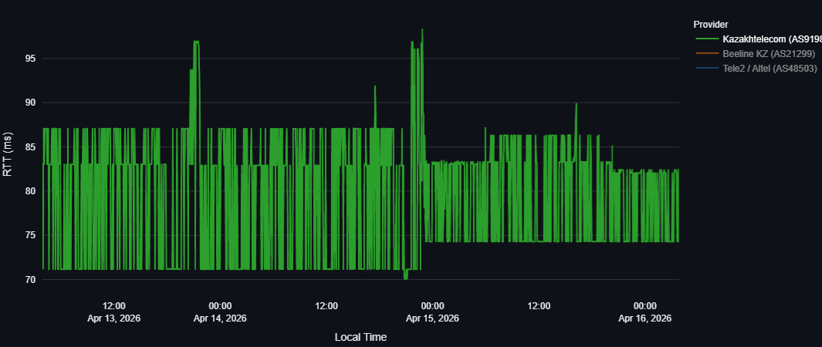

Figure 2: RTT timeseries for Beeline KZ.
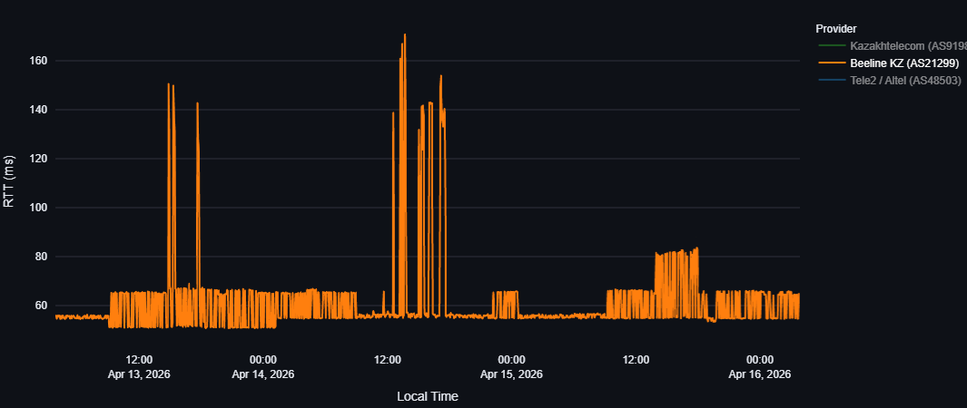
Figure 3: RTT timeseries for Tele2/ Altel.
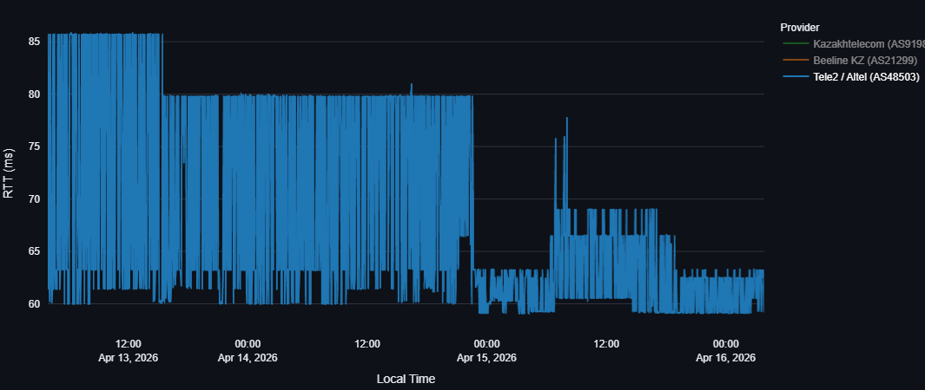

Figure 4: Cross-provider RTT overlay.
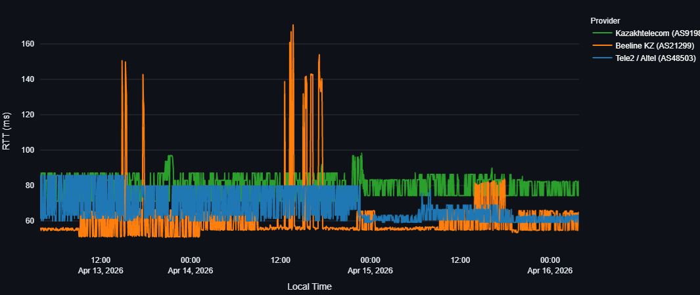
Figure 5: RTT distribution across providers during the common window.
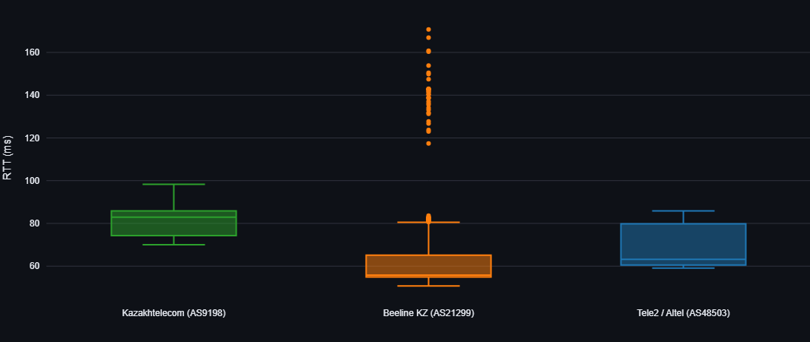
3. Engineering Conclusion & Root-Cause Reasoning
Baseline Performance and Variance
Looking at the plotted API data, there is a clear difference in how each ISP routes international traffic to Facebook's CDN. The boxplot (Figure 5) provides the best summary of this baseline behavior. Beeline KZ maintains the lowest median latency at around 55 ms, showing that its primary transit path is the shortest. However, this comes at the cost of stability. Tele2 sits in the middle with a median of roughly 63 ms, while Kazakhtelecom operates on a noticeably higher baseline (median ~82 ms).
Despite having the highest base latency, Kazakhtelecom’s routing is highly predictable. The green timeseries shows continuous, dense jitter within a strict 71-87 ms band, which is typical for load-balancing across multiple parallel links. More importantly, Kazakhtelecom has almost no extreme outliers, meaning its transit capacity is sufficient to handle peak loads without severe queuing delays.
Severe Congestion Anomalies
Beeline’s performance profile is completely different. While its baseline is low, both the timeseries and the boxplot reveal massive, isolated latency spikes reaching up to 170 ms (mostly visible during the daytime hours on April 13 and April 14). Since the overlay graph (Figure 4) proves that these spikes are not synchronized with the other providers, we can rule out a global issue with Facebook's servers. Instead, these anomalies point to temporary bandwidth saturation (bufferbloat) at one of Beeline’s specific international peering exchanges or a flapping BGP route.
Routing Shifts and Anycast Optimization
The most interesting network event in the dataset belongs to Tele2/Altel. Up until midnight on April 15, the blue graph shows a high variance band oscillating between 60 ms and 86 ms. Then, a sudden and permanent shift occurs. The upper ceiling of the latency drops drastically, and the connection stabilizes in a much tighter band around 59-69 ms for the remainder of the observation period.
This behavior is not caused by a simple drop in user traffic. It is a textbook example of a BGP route optimization or an Anycast Instance Shift. Around that time, either Tele2’s routing protocols discovered a more optimal path, or the Facebook CDN redirected the probe to a closer edge-node, immediately cutting out about 20 ms of routing overhead.
Summary
Overall, the lack of synchronized anomalies across the overlay graph confirms that performance degradation in this scenario is tied entirely to the specific upstream conditions of the local ISPs, rather than the target CDN. Each provider utilizes distinct transit links, resulting in unique latency signatures: Beeline offers the shortest but most volatile path, Kazakhtelecom provides a longer but highly stable route, and Tele2 demonstrates active, dynamic path optimization.

4. References
- RIPE Atlas Measurements API. Available at: https://atlas.ripe.net/api/v2/
- "BGP Routing and Anycast CDN Load Balancing," Internet Engineering Task Force working drafts.
- RIPE Atlas Probe Network Map and Architecture Documentation.

